Hierarchy from Atoms to Organisms

Introduction
- So you might be wondering what is the correct order and correct interpretations of the smallest parts to the biggest part from the cell to an organism.
- So today we are going to talk about the hierarchy from atoms to organisms. Are you ready? Let's explore!

Exploring to the Topic
- Check this hierarchy from atoms to organisms! What do you observe?

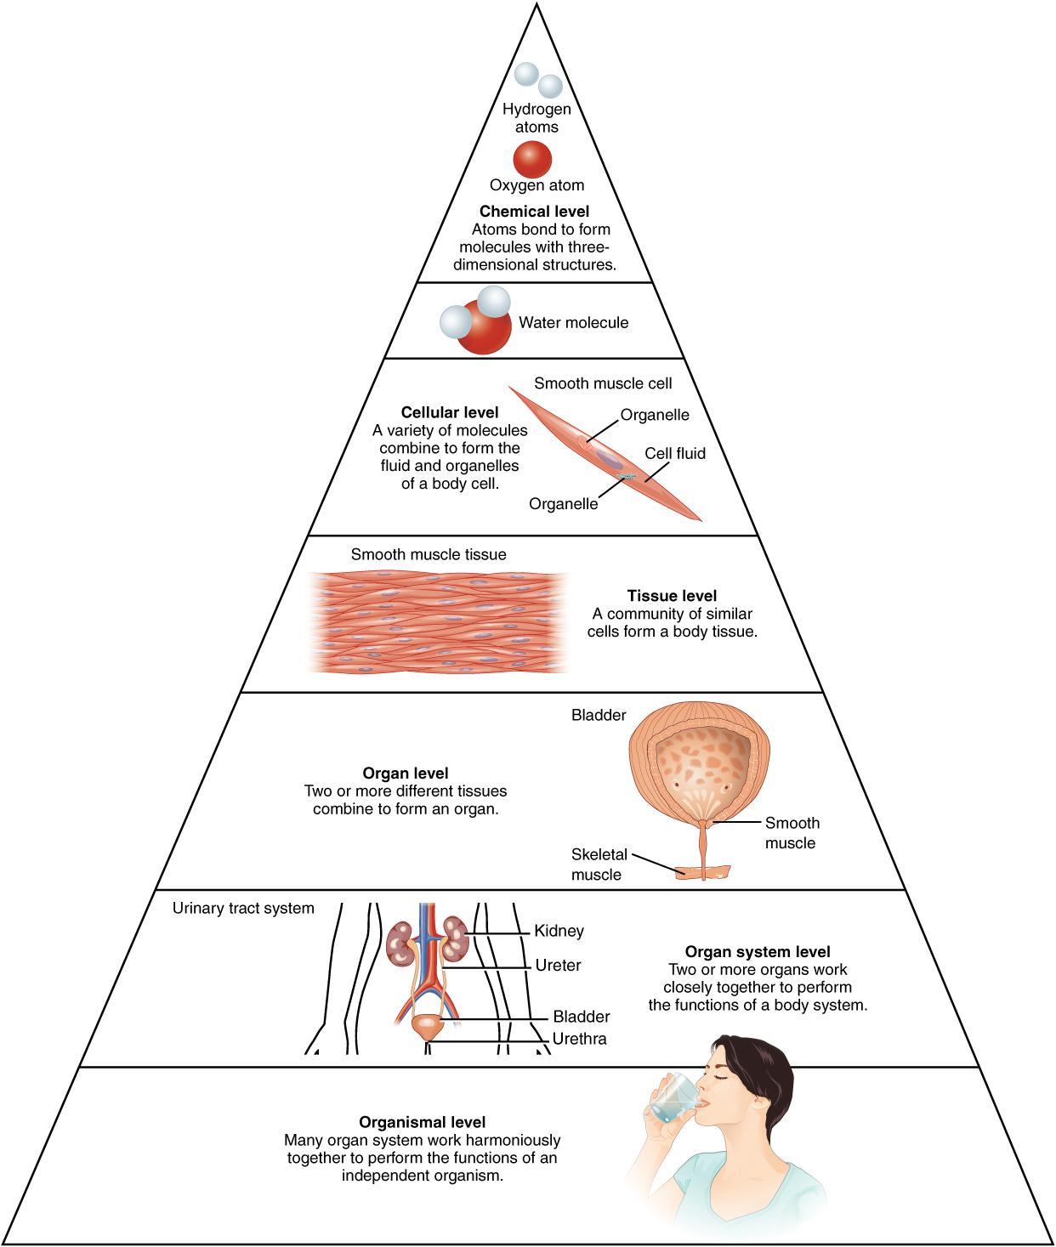

Guide questions:
- How many classifications do you see?
- Why do you think these are important to learn?

Lesson Discussion

Let us now hop to our topic!!!

The hierarchy starts with…

1.Atoms! Specifically hydro atoms

What are atoms?

Atoms are building blocks of elements and are the smallest particles. They are small enough to not be seen in a regular microscope. Atoms build elements which can give us many functions to help us organisms live! Do you think there is something smaller than an atom?

What is the function of an atom?

- Everything is made up of atoms! Millions of organisms wouldn't survive without atoms in a day or two. It helps enhance our daily life and helps us survive more easily.

2.Elements/compounds! Specially oxygen(O) and carbon dioxide (C₂O)

What are elements/compounds?

Elements/compounds are the most important thing that has ever existed. They are made up of atoms.They can be seen through most of our materials like gold being seen in a gold bar.How long do you think an organism would survive if elements did not exist?

What is the function of an element/compound?

- Elements combine with other elements to form important compounds in our life like carbon dioxide.

3.Cell

What are cells?

Cells are the smallest and basic unit of life. There are red and white blood cells each giving us a different function. The cells combine together to make another unit that we will discuss later on as we go on to our lesson. Do you know what the types of cells are?

Red blood cells / erythrocyte

- Erythrocytes are cells that transport oxygen to the lungs and release carbon dioxide from the lungs.
- Without erythrocytes, we cannot function the respiratory system and lead to your sad death.

White blood cells / leukocytes

- Leukocytes fight infections and diseases to protect your human body.
- Without leukocytes, we could get sick easily and eventually and probably would lead to a sad death.

4.Tissues

Tissues are groups of cells combined working together to form a function that could be important for our human body. What different types of functions do you know when we are talking about tissues?

What is the function of a tissue? (Not the one you use to wipe things)

- Tissues create movement, protection and support to our human body.
- Without them, there would be no framework for our beautifully made human body.

5.Organs

Organs are a group of tissues connected that helps our body function better and helps a “secret word” survive better. Do you know what the secret word is?

Note: If they said no, say aw, that's sad.
Note: If they said yes, ask for what it is.

What are the functions and examples of an organ?

- Digesting food (stomach)
- Pumping blood (heart)
- Thinking (brain)
- Doing actions (bones)

6.System

A system is a group of organs that work together to help organisms do a specific action. How many organ systems do you think we have?

What are the functions and examples of a system?

- They help organisms breathe (respiratory system)
- They help organisms eat (Digestive system)
- They help organisms move (Skeletal system)

7.Organisms

An organism is a living thing made up of over 10 systems, like us! What examples of organisms do you know?

The only function of an organism is they help our planet be balanced.

References:
Google (2025) “Atoms” google.com/search?q=atoms
Google (2025) “The functions of atoms” google.com/search?q=Theq=functionsq=ofq=atoms
Google (2025) “Elements (Biology)” google.com/search?q=elements
Google (2025) “The functions of elements (biology)” google.com/search?q=Theq=functionsq=ofq=elements
Google (2025) “Cells” google.com/search?q=cells

